LINUX PROGRAMMING - SWE4009

LAB ASSIGNMENT – 3

DATE : 19/12/2019

NAME : ANJANA P

REG NO. : 17MIS1028

1.) Write a shell script to search for a string in a file.

SCRIPT:

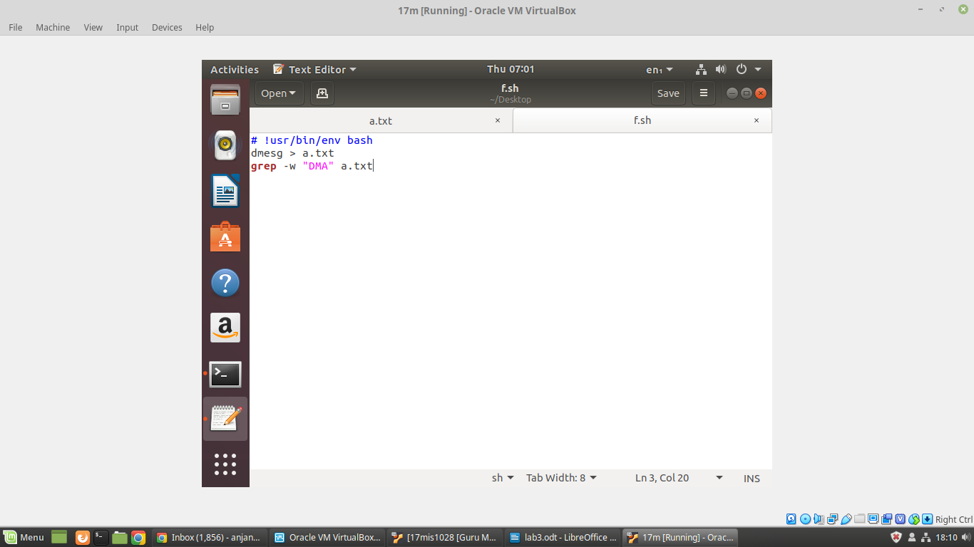

SCREENSHOT :

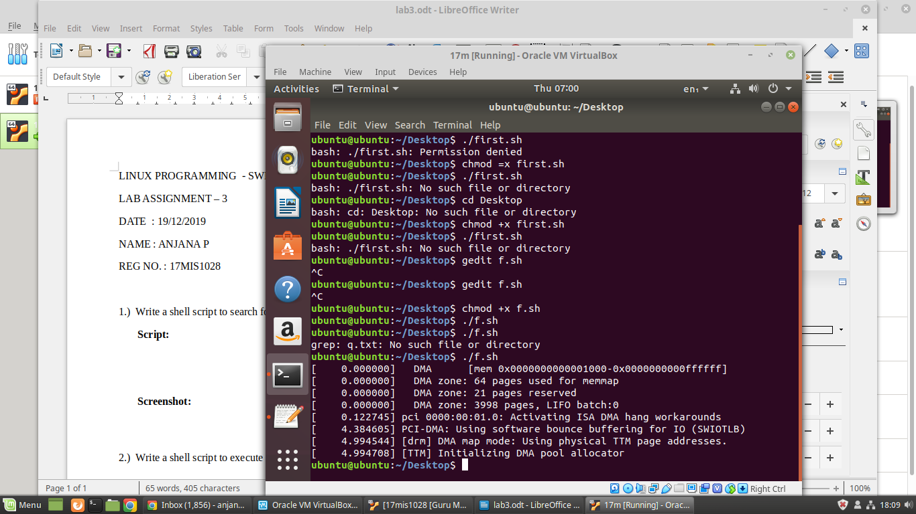

2.) Write a shell script to execute a while loop.

SCRIPT:
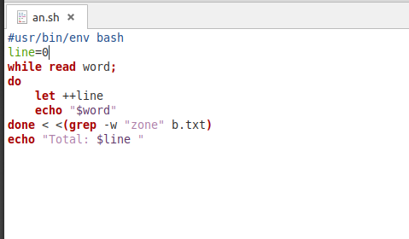

SCREENSHOT:

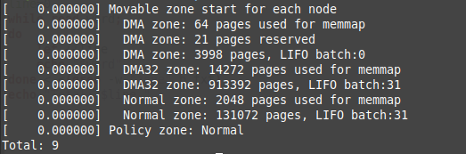

3.) Write a shell script that will check the log file every hour to check for errors and display the
error message.

SCREENSHOT:
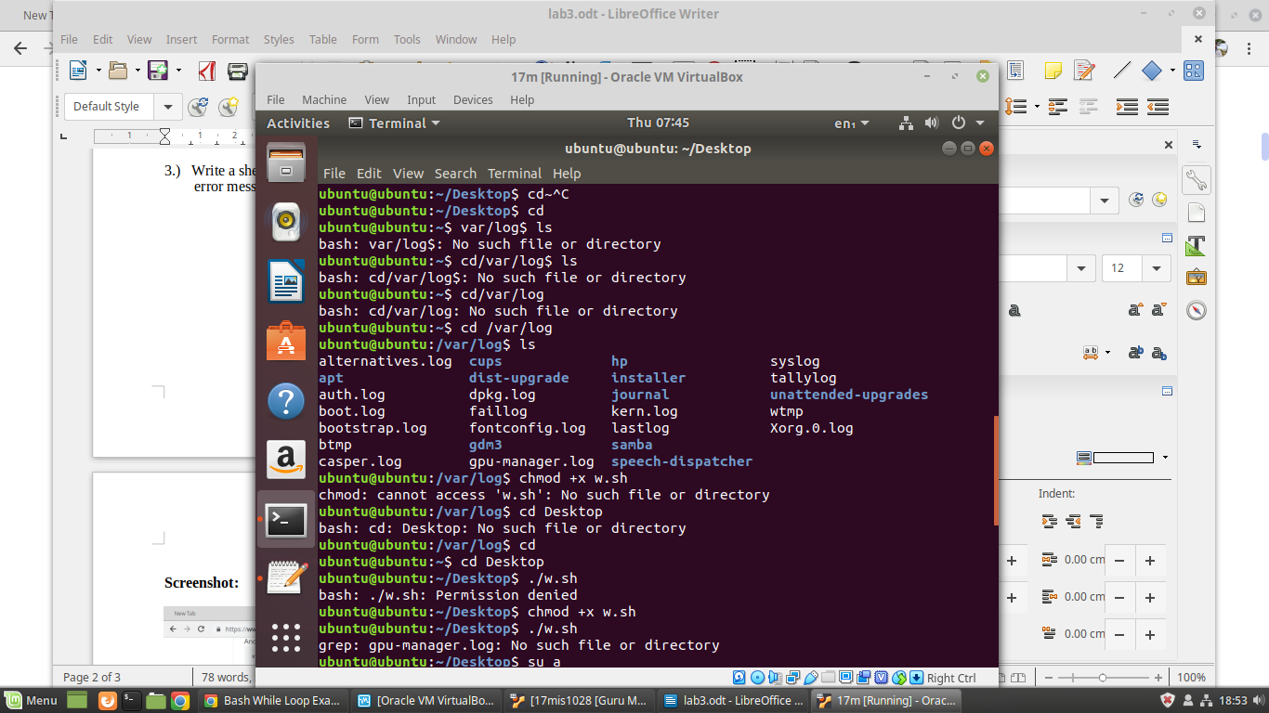

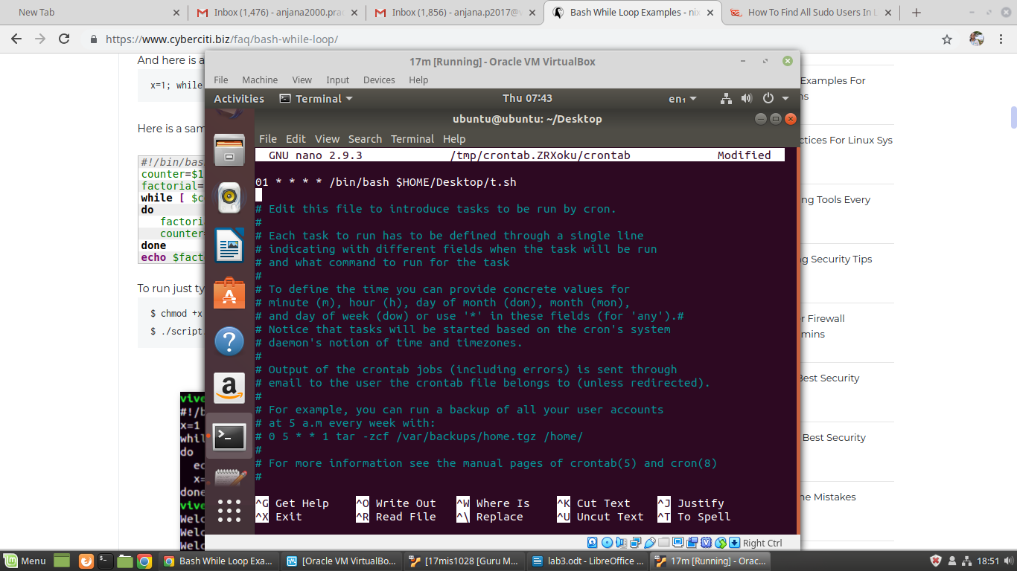

4.) Write a shell script to measure the performance of CPU.

SCRIPT:
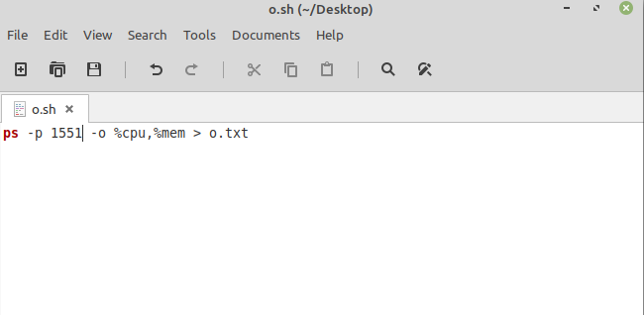

SCREENSHOT:
